DESIGN AND ANALYSIS ALGORITHM
Name: G.Ragavendar
Roll no:ch.sc.u4cse24260
1) Bubble sort :
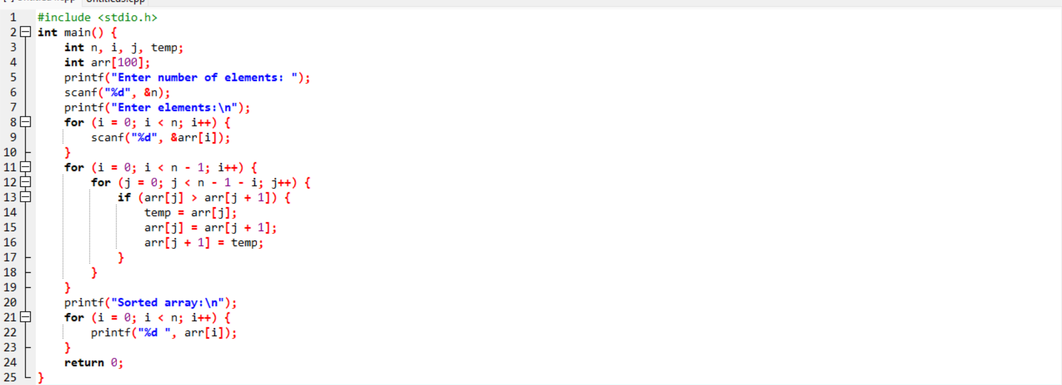
O/P:
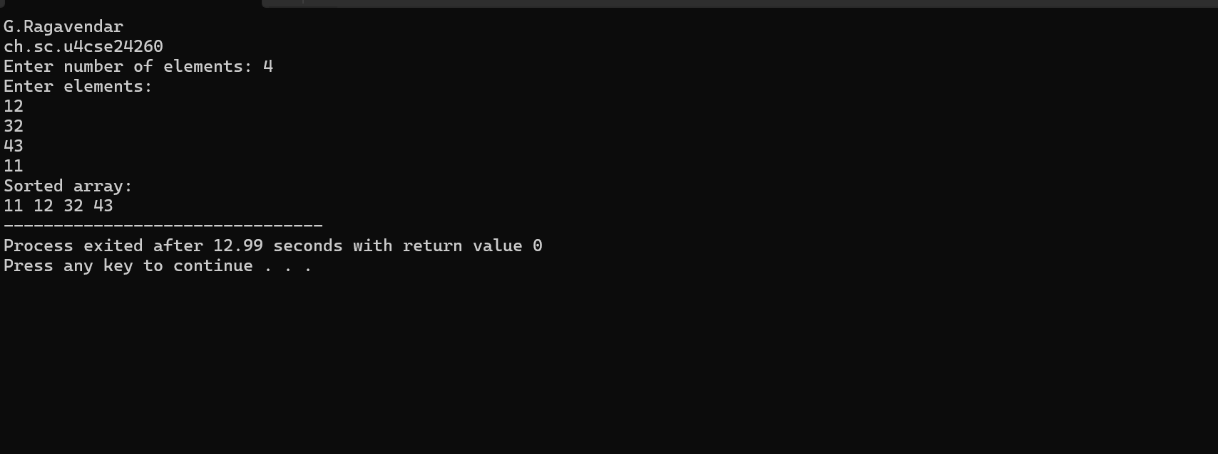
Interpretation:
It checks two neighbouring elements at a time and swaps them if they are in the wrong order.
With each round, the largest number slowly moves to the end.
2) Insertion sort :
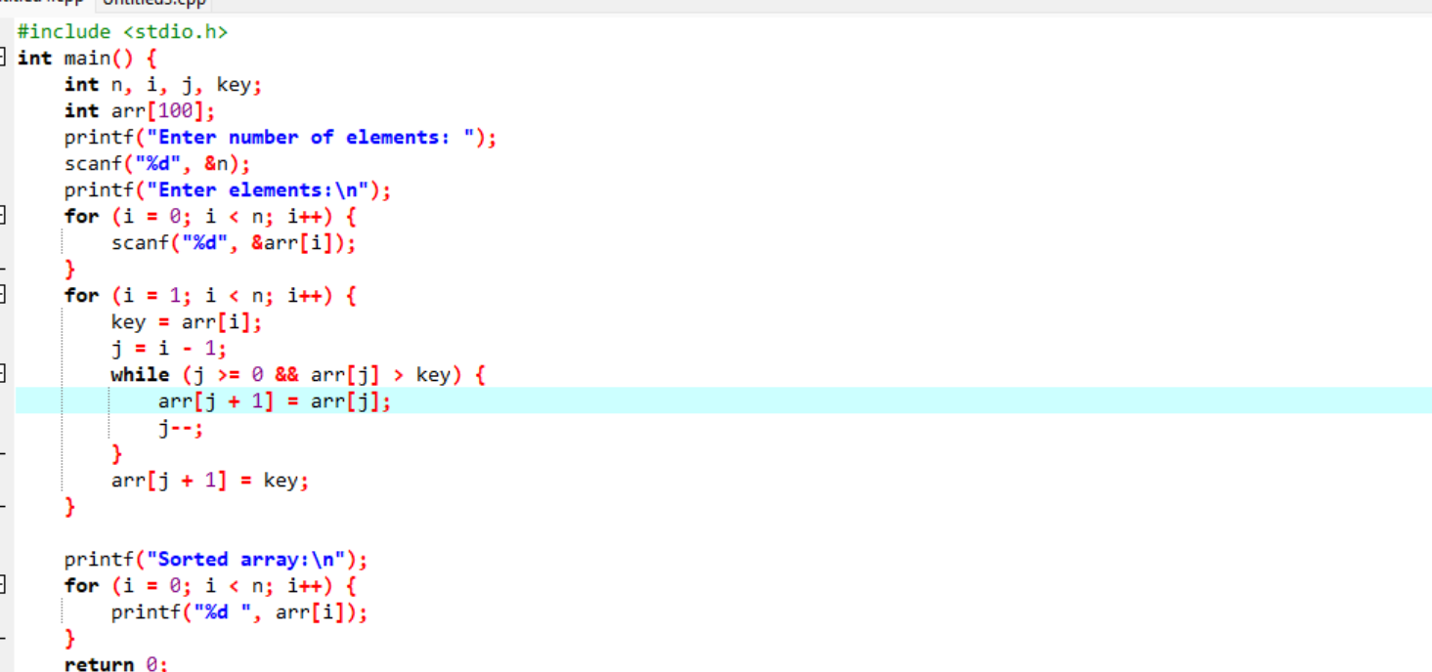
O/P:
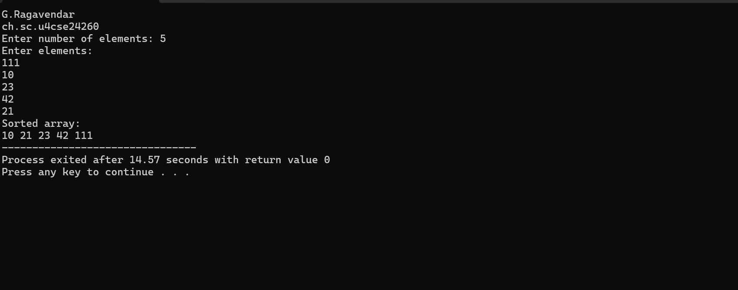
Interpretation:
Take one element at a time and place it in its correct position among the already sorted elements.
Larger elements are shifted to the right to make space for the current element.
This process continues until the entire array is sorted neatly.
3)Selection sort :
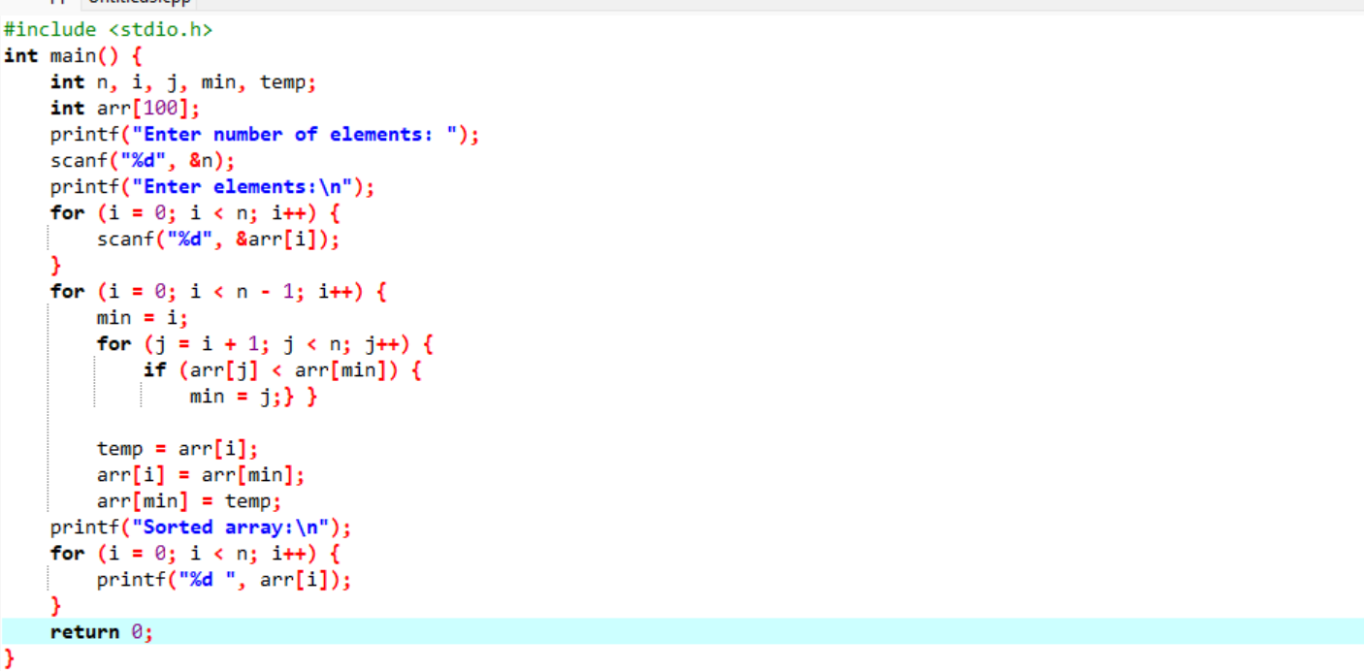
o/p:
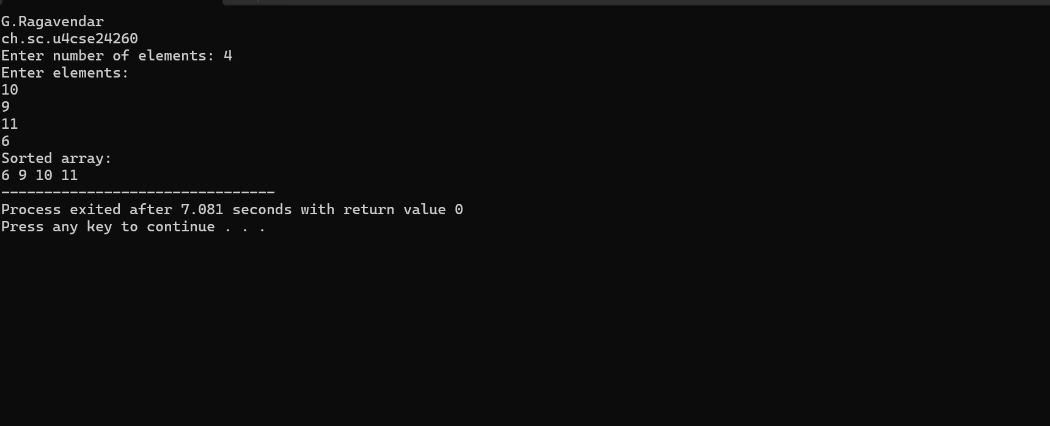
Interpretation:
Selection Sort works like picking the smallest item again and again.
You look through the entire list, find the smallest number, and place it at the beginning.
Then you repeat the same process for the remaining unsorted part of the list.
4) Heap sort:
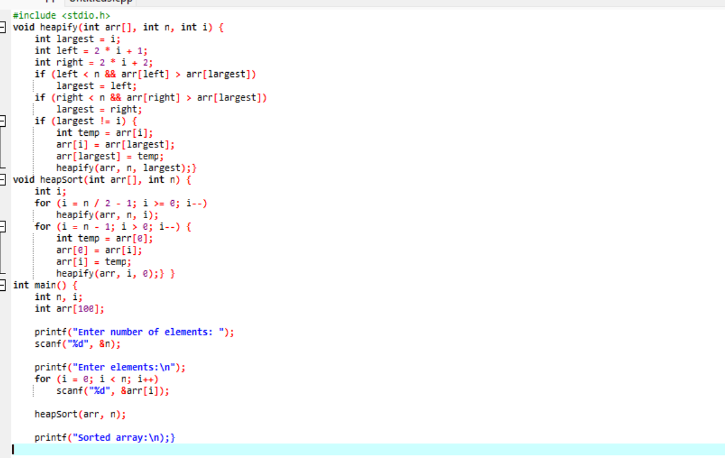
o/p:
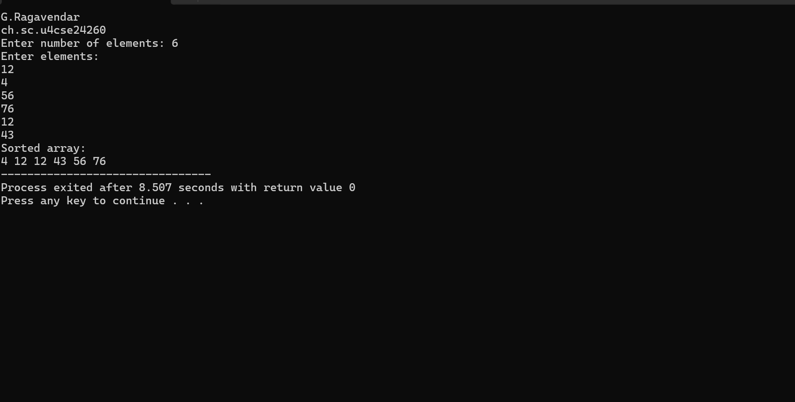
interpretation:
First, the largest number is brought to the top, like the most important item.
That largest value is placed at the end, where it belongs.
The process repeats for the remaining elements until everything is sorted.
5) Bucket sort:
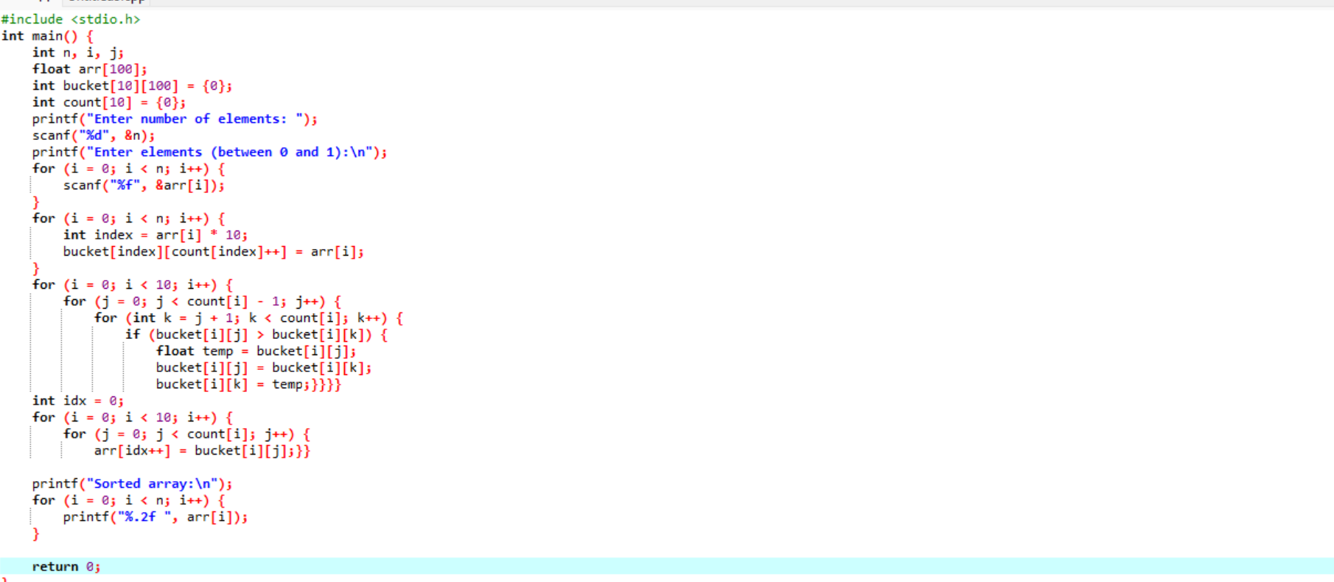
o/p:
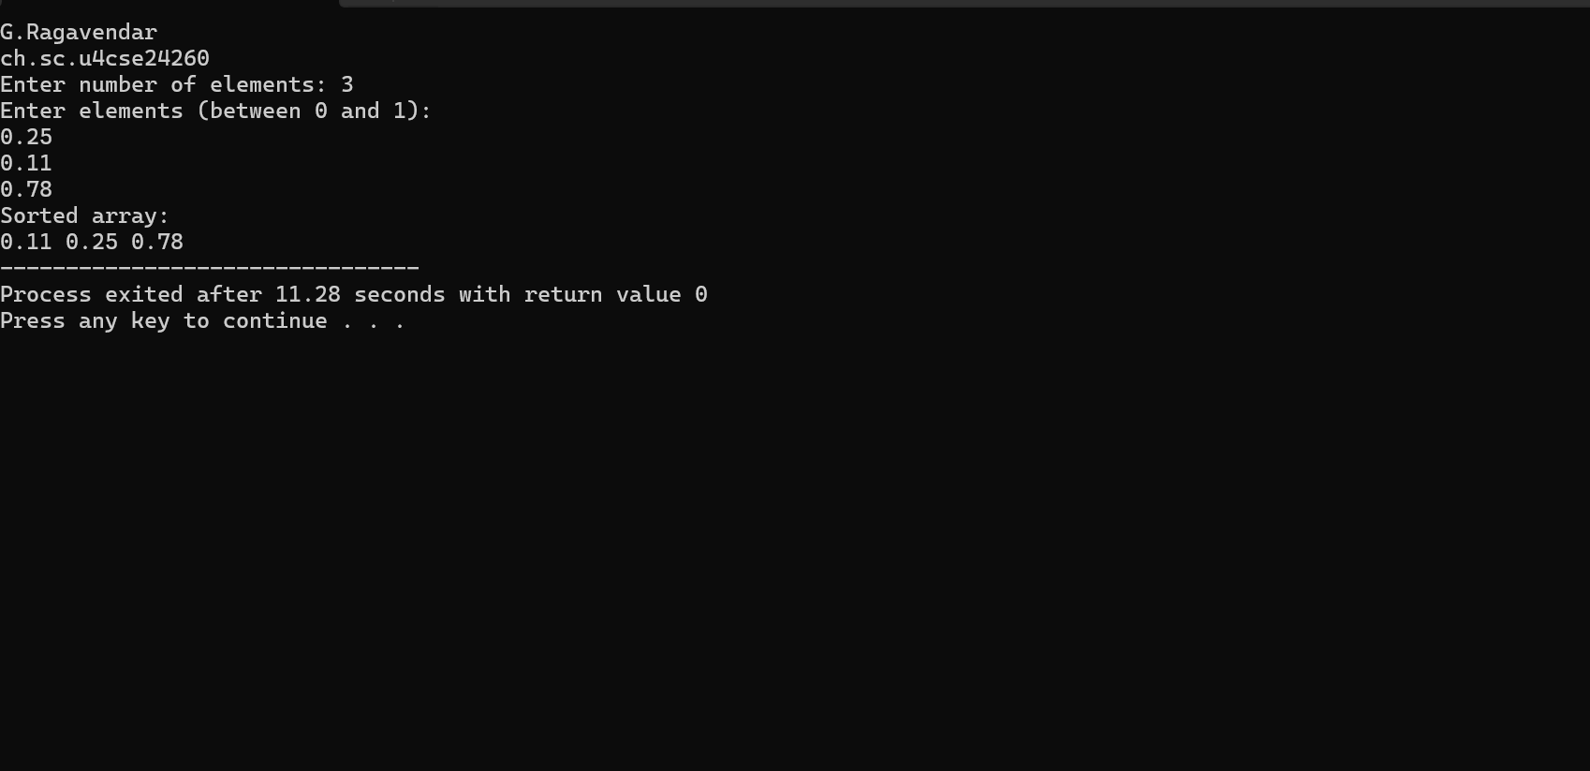
Interpretation:
Bucket Sort works like putting items into different boxes based on their value.
Each number is placed into a bucket that matches its range.
The numbers inside each bucket are then sorted separately.
Finally, all the buckets are joined together to get the fully sorted list.

